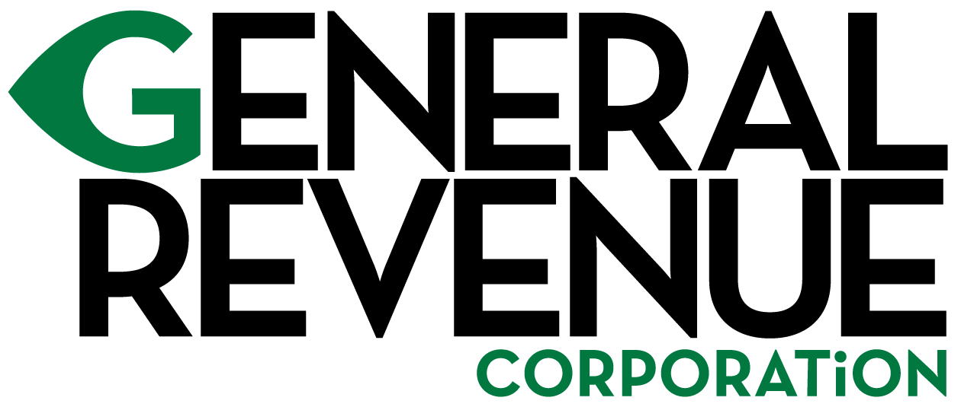
PLANNED SYSTEM MAINTENANCE
General Revenue Corporation’s website is undergoing system maintenance and will be unavailable Friday, November 13, 2020 at 7:00 PM EST through Monday, November 16, 2020 at 11:00 PM EST. Please revisit our site on Tuesday, November 17, 2020 to resume website activity. We appreciate your continued support and apologize for any inconvenience this system maintenance outage may cause you. Thank you.

